Field Rotation Angle Equations

# Altitude and Azimuth Equations

The altitude (E) and azimuth (A) of a celestial object can be related to the observer's latitude (φ), the object's hour angle (H), and declination (δ) as follows:

sin(E) = sin(φ) sin(δ) + cos(φ) cos(δ) cos(H)

cos(E) cos(A) = cos(δ) sin(H)

cos(E) sin(A) = cos(φ) sin(δ) - sin(φ) cos(δ) cos(H)

# Field Rotation Angle in Alt-Az Coordinates

The field rotation angle (θ) for an alt-az telescope can be derived by considering the change in the position of the object in the sky relative to the telescope's axes. The Parallactic angle is given by:

P = arctan( cos(φ) sin(A) / ( cos(A) sin(E) - sin(φ) cos(E) ) )

Considering there is no K-Mirror in the optical path, the rotation of the field reference to the celestial north pole would be:

$$NPA= P+E+\left(180°-IBA\right)sin(E) -180°$$

IBA is the instrument bearing angle and is equal to 174.5 degrees.

To express the field rotation angle in terms of the hour angle (H) and declination (δ) of the object:

P = arctan( cos(φ) sin(H) / ( sin(φ) cos(δ) - cos(φ) sin(δ) cos(H) ) )

So:

$$NPA= P+E+\left(180°-IBA\right)(sin(φ) sin(δ) + cos(φ) cos(δ) cos(H))-180°$$

Or

$NPA= P+$ arcsin(sin($φ$)sin(δ)+cos($φ$)cos(δ)cos(H)) $+\left(180°-IBA\right)(sin(φ) sin(δ) + cos(φ) cos(δ) cos(H))-180°$

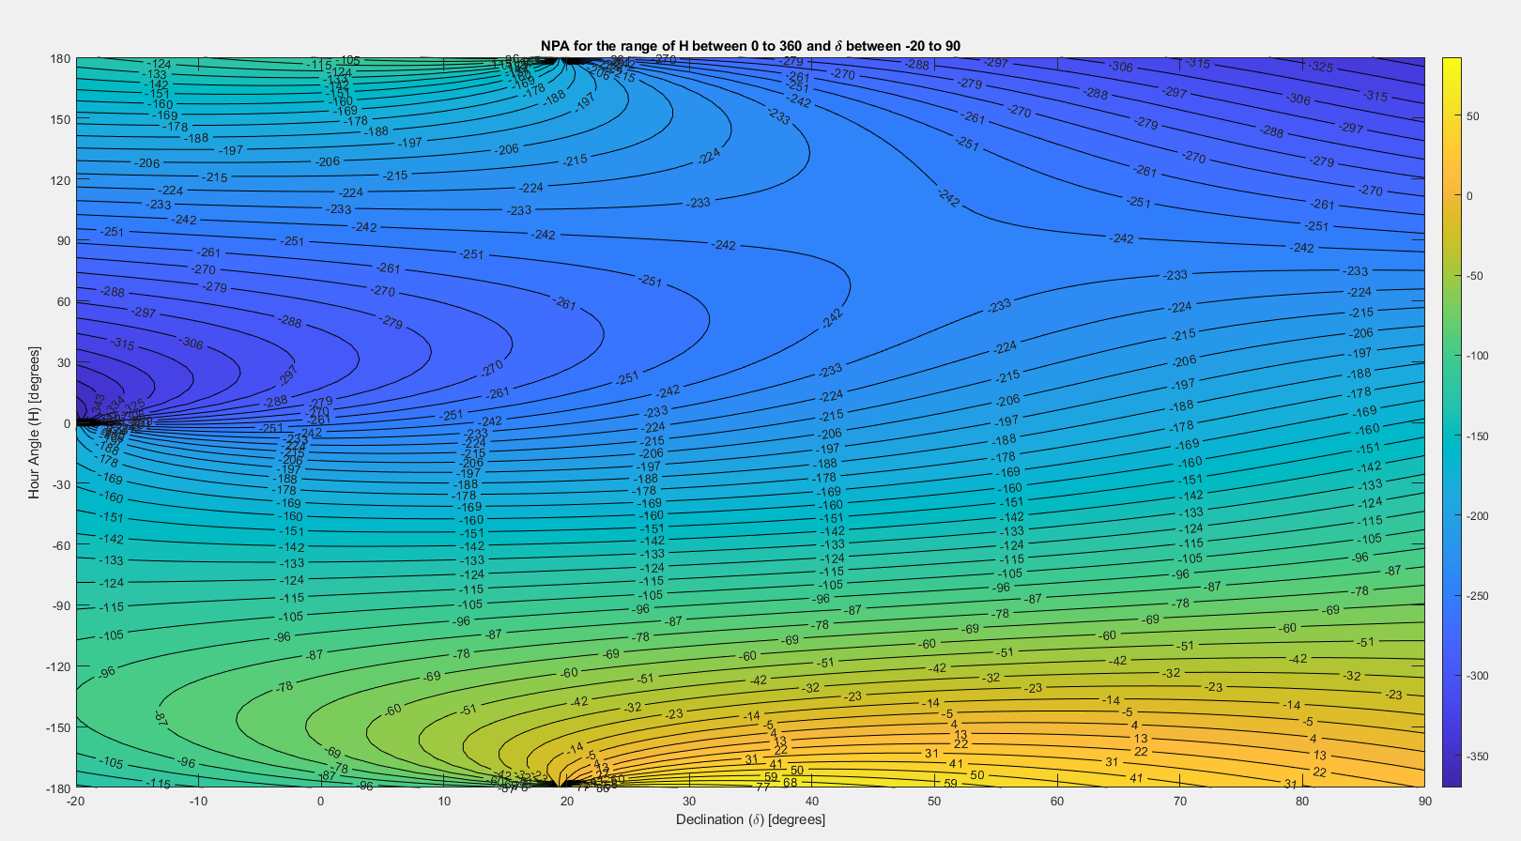

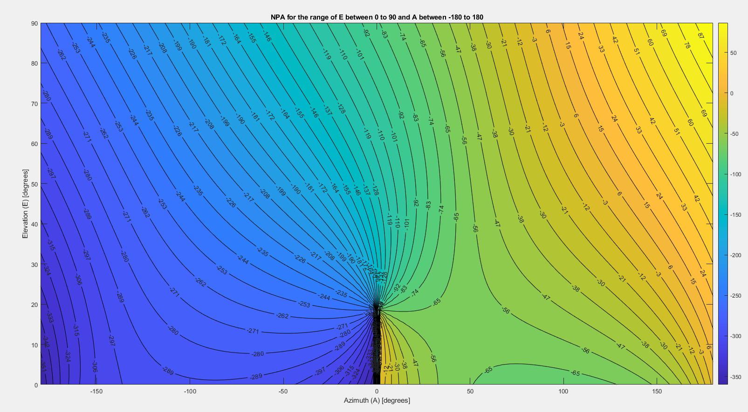

M3 Orientation

# Altitude and Azimuth Equations

The angle between the incoming chief ray and the normal of M3 as can be calculated as Φ. The tip of M3 also is mentioned below as θ.

θ = arctan(sin(E) sin(IBA) / cos(IBA) )

Φ= arccos(-cos(E) sin(IBA))/2

Please see the two figures below for a clearer image on the position of these angles.

